
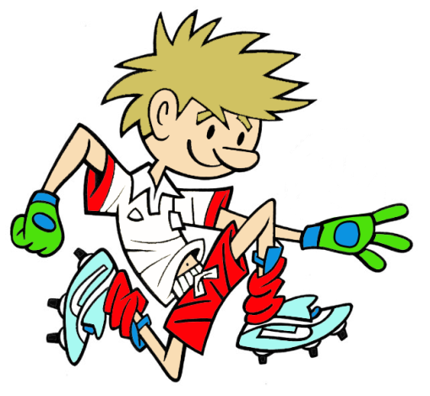

RULES – HOW TO PLAY

Mark out an area with 4 cones in a zig zag formation about 1m apart diagonal from each other as shown

Run around the outside of the cones, planting the outside foot to drive off

When they reach the red cone, throw the hoop over the cone

Pick up hoop

Run straight back and ‘high five’ the next child to go
FOCUS
In this activity we are developing the player’s ability to change direction as quickly as possible

STATION 1: AGILITY
Activity: Round The Towers
HARDER
- Move the cones closer together
- Reduce the size of the hoop to throw over the cone
- Go backwards one way, then forward another way
- Use hopping, jumping as means of travel

EASIER
- Spread out the cones
- Move the small cone closer to the bigger cone to throw the hoop at

COACHING POINTS

HEAD
- Keep the head up watching where the cones are
- Keep looking where you hope to move to next

HANDS
- Hands up ready to turn
- Use arms to help balance your body as you run

FEET
- Move on balls of feet and bend knees as you change direction
- Plant the outside leg to drive off but...
- Use the inside front part of this foot to drive off
EQUIPMENT

- 2 Domes

- 5 big cones

- 1 hoop

Copyright Ulster Council GAA 2009

